**Defining Open Float Liquidity Pools**

lntermediare term basis is around 3/4 months Every quarter large liquidity pools will be targeted

Open float is simply taken the last 3 months or taking last 1.5 month to the next 1.5 month in the future and marking that time, basically you look at 3 months of data

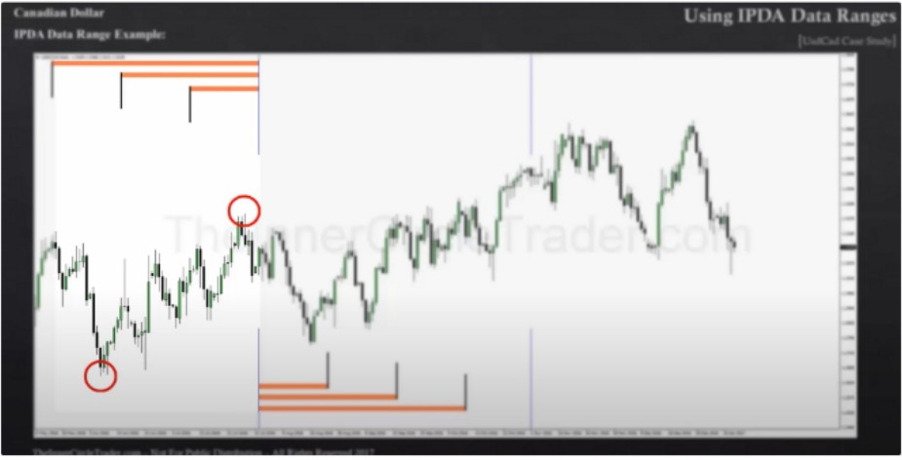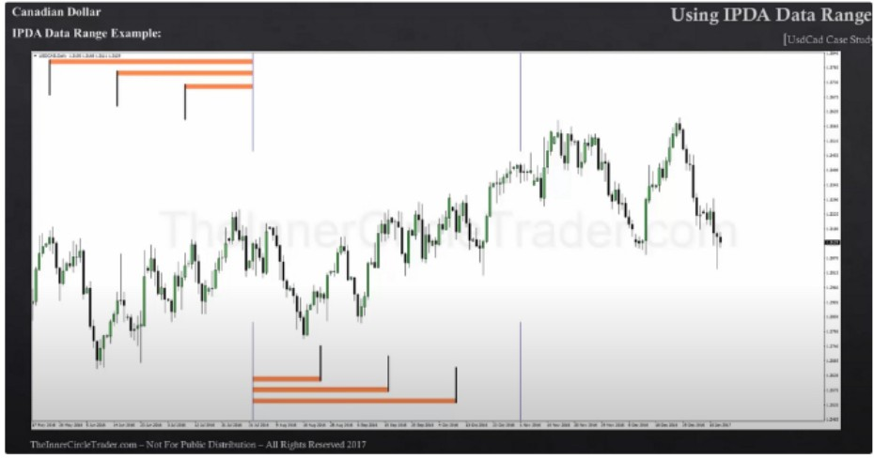

When you have the high and low of the lookback of 20, 40, 60 days and you cast forward then thats your open float. You want to find the highest high and lowest low in between those 2 reference points in time

On a near term basis we can look back 60 days and look what the range was, the high and low

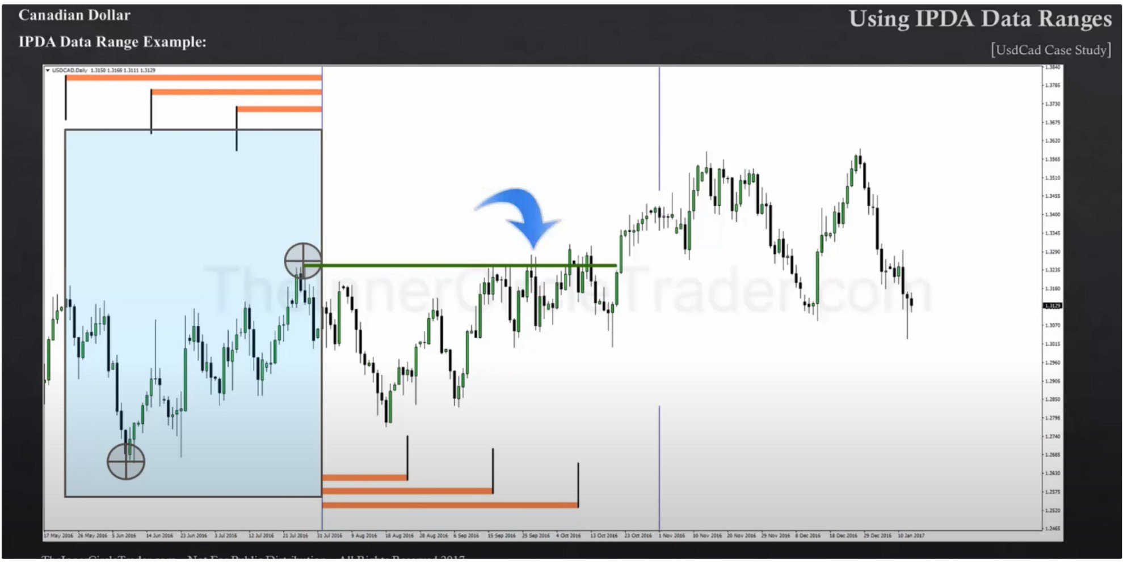

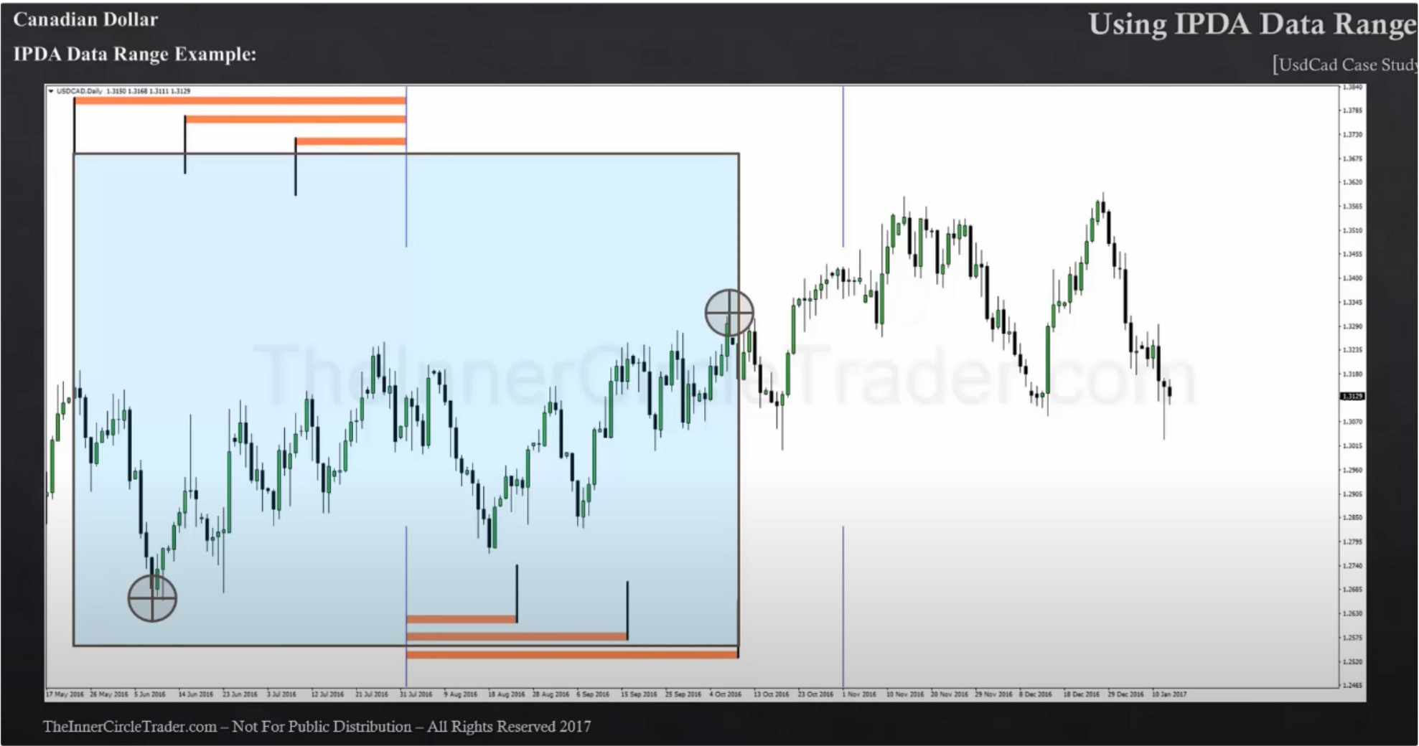

This example above is your total open float

Look at where the near term low/high is in the last 20 days, where is the short term low/high in the last 40 days and where intermediate term high and low in the last 60 days.

So the next 20 trading days we can expect a range of high and low to form. Noting what that high and low is of the last 20 days will give us the liquidity pool on the near term basis. Near term highs and lows are very useful for scalping and intraday

When we look out 40 days, it gives us a little bit more of a short term basis for defining the liquidity pools on the daily chart. Looking for the last high and the last low.

60 day cast forward will give us the boundary point of where the open float will end in terms of time.

So were looking 60 days forward and looking back 60 days. So we have a 120 trading days of what we call the open float, and were looking highest high and lowest low in that range.

But every 20 days theres a high and low formed

Also notice that the buy stops get hit, and the sell stops almost never gets hit, by default this teaches you that institutional orderflow is bullish

Large funds are long term trends trader, like the turtle traders. Thats where the name turtle soup comes from

(e) Embed anything (P[

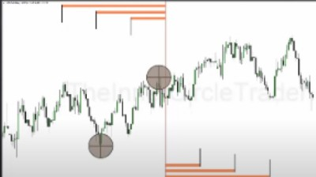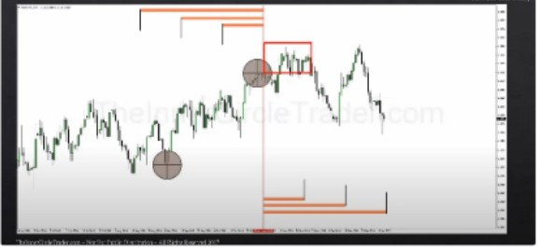

He uses this for every new month, from what ive seen now

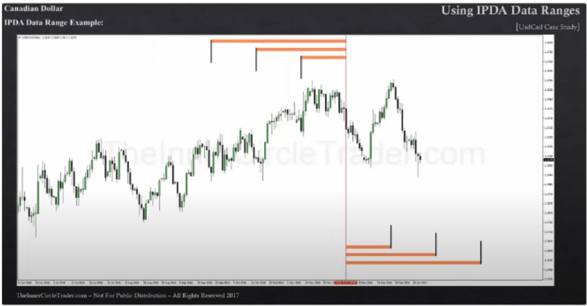

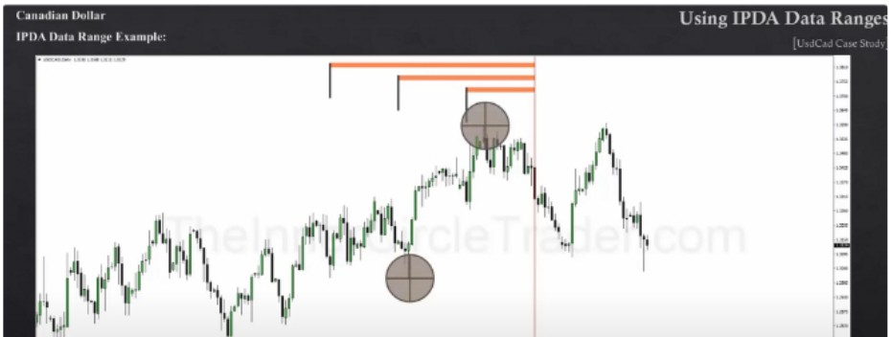

_j

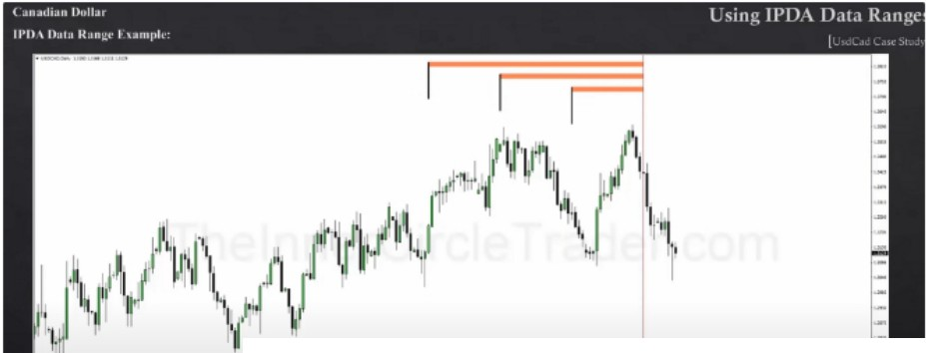

;:::_j===- JI:

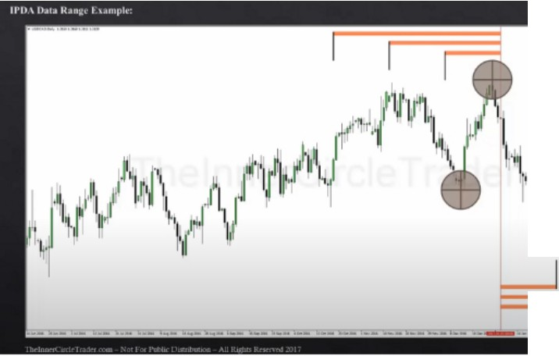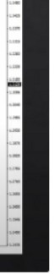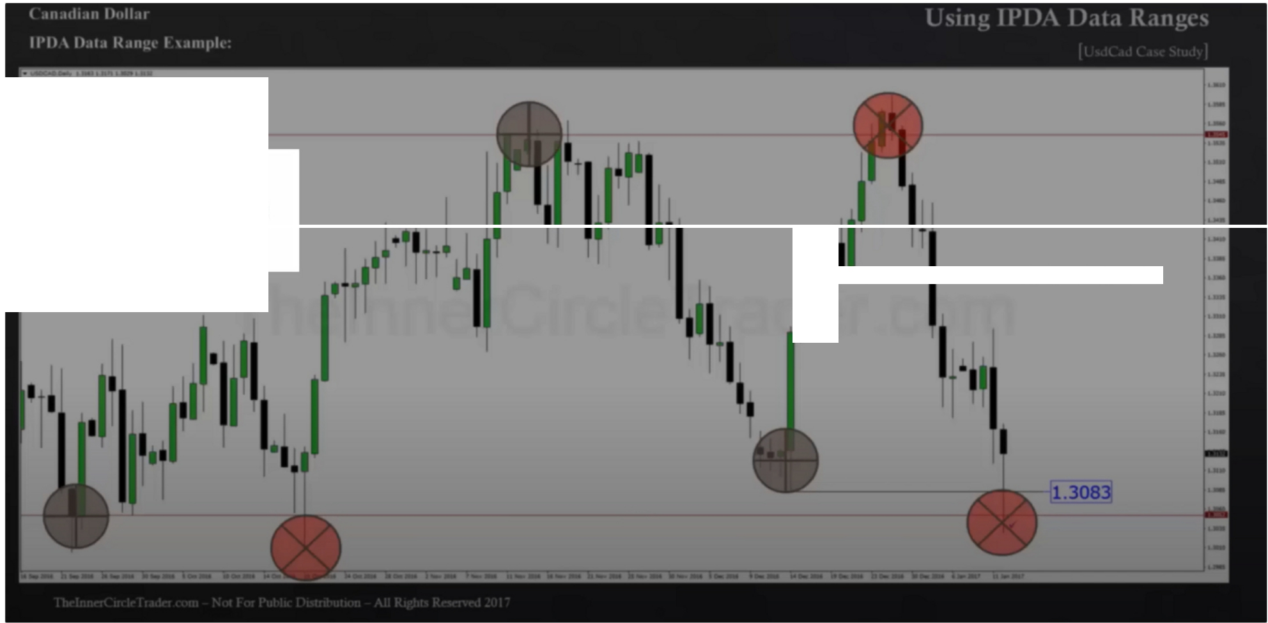

**NotePad Moment!**

j•1

. ..-

What makes these false breakouts so lucrative, is the fact that we know large fund traders have their stops above and below these lows. Every 20 trading days theres going to be a new liquidity pool formed, its going to be on the buyside and on the sellside. You just have to identify where those ranges are in respective terms where the most obvious swing highs and swing lows have formed and then frame then going forward, wheres the next 20 days high and low. Looking back the last 60 days and looking forward 60 days gives us the range for open float, the highest high and lowest low in that range of a 120 days thats where the large funds macro is, thats where theyre aiming for buy stops and sell stops are.

We just monitor as price creates new highs and lows, where are we in relative terms to the last 60 trading days, are we making a higher high higher then the highest high? Or are we making a lower low lower then the lowest low in the last 60 days. And we look forward 60 trading days in the future and we keep moving that basis forward each new month and well eventually arrive at the institutional orderflow by default you can see where theyre running the market. Theyre taking out buystops constantly and rarely take sellstops, thats telling you they want to keep pushing higher.

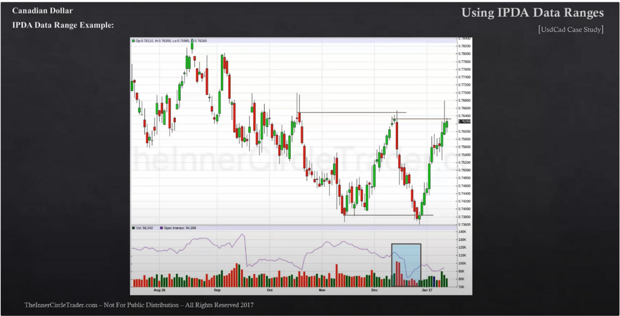They keep grinding the large funds. Vice versa when bearish. This is how you establish institutional orderflow. We keep watching the last 60 days and where are we in relation to that, are we above it or below it, if were above it then we have to continue seeing buy stops get taken out, if we start seeing sellside get taken out we're probably making a quarterly shift. Vice versa when bearish and were below the last 60 days low, then were really oversold and when we start seeing buystops getting taken out and rarely sellstops then were probably seeing a quarterly shift happening, a new direction of the market place.

Combine this with open interest for quarterly shifts when the market trades to a support leve

If open interest is declining that means theyre not willing to offer sellside liquidity to buyers, so theyre scaring those individuals by dropping it quickly. Open interest shows that smart money is not interested in being short, high open interest is a indication that theres a big massive liquidity program offered for buyers. The bank is offering that as risk. But if open interest declines and the market declines and goes into a support level

The markets move based on very long term fundamentals, but we can still make use of the manipulation in between

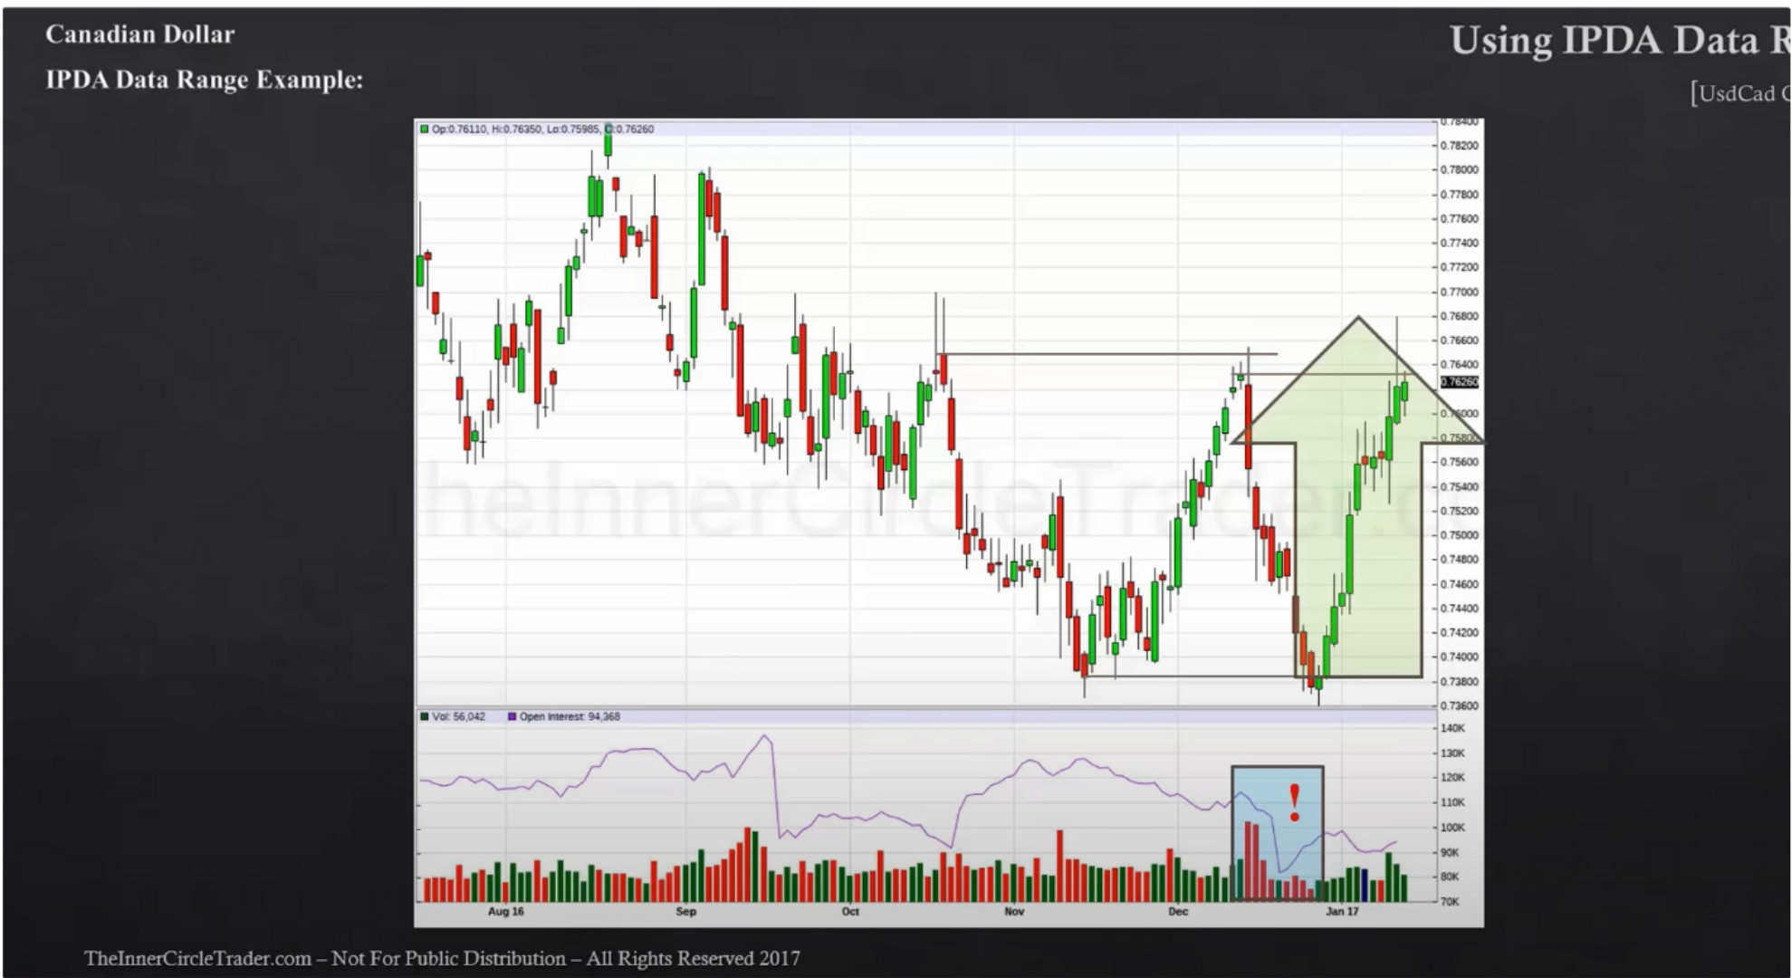

Low open interest at a support level at a time where the stops have been ran out below the market place thats indicating potential strength

If the market is constantly taking SSL and rarely BSL then focus on shorts and that means institutional orderflow is indicated lower. Until we get an obvious change of direction, how would that happen? Well if we trade below the last low of the last 60 days were probably in very very deeply discount even if it bounces only a little bit, thats a lot of opportunity on the lower timeframe and then it could continue lower after

To make it simple, what youre looking for is a revolving continues range of 120 days (the open float) and whatever day you're looking at you look back 60 and you look forward 60 and youre constantly monitoring where is the highest high and the lowest low in that range and thats where the buy stops and the sell stops are going to be. The lookback phase is where the hard stop are going to be that means where the actual buy and sell stops are going to be. But if were looking forward studying new price action as it occurs you need to be mindful of of where you are in the last 60 days range, are we near a high or are we near a low? And thats also going to be indicative of where were going to see the next quarterly shift. If its going to be continuasly moving higher higher and higher keeps taking BSL, (unless were parabolic range that ICT will teach later), generally the market moves from range to range.

This concept is very benificial because we can see where the near term high and low is (20 days high and low) and to repeat: the next near term move is going to run on near term buy stops or sell stops and that means the last 20 days range thats the near term open float.

The short term open float is whats the highest high and lowest low of the last 40 trading days

And the intermediate open float is the 60 days highest high and lowest low

Knowing where you are in that range and which side of the market keeps getting taken out will give you clues as to what the next shift in price is going to be, once it starts to break you know youre going to have a significant price move and you can trade that accordingly even on the daily chart.

Arjo I Twitter, lnstagram I Linktree

Linktree. Make your link do more.

, https://t.co/HhmmTN1fUI

JavaScript is not available.

"# https://twitter.com/arjoio